WANTED:
ASHLEY GENTLE
RULE BROKEN:
- BROKE THE ATTENDANCE POLICY
LAST SEEN:
- GETTING IN HER CAR IN THE JUNIOR BOWL ON 10/21/2017
REWARD:
- $500
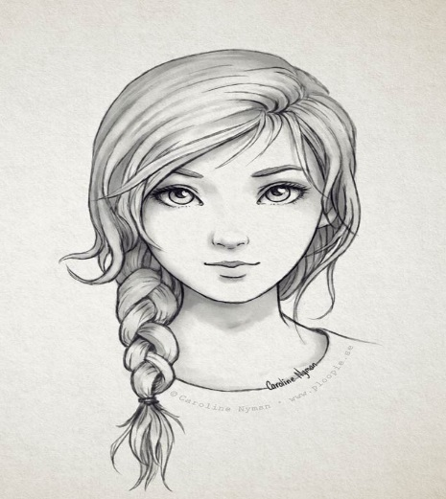

SHE HAS BLUE EYES AND LONG DARK BROWN HAIR, SHE USUALLY WEARS MAKEUP. SHE WAS LAST SEEN GETTING IN HER BLUE TOYTA HIGHLANDER.

